Particular | Details
Student Name | Vasireddy Sree Ruthin Reddy
RegNo. | 192324112
Department | AI&DS
Programme | B.TECH
Course Code & Course Name | CSA0702-COMPUTER NETWORKS
Academic Year / Batch | 2026–2027 / 2027 Batch
Faculty Name | Dr. R. Senthamil Selvan
Assignment Title | VLAN-Based Enterprise Network Design and Inter-VLAN Routing
Date of Issue | 02-09-2026
Date of Submission | 02-09-2026
Maximum Marks | 100
Course Outcome(s) – CO | CO1, CO2, CO3, CO4, CO5
Bloom's Taxonomy Level | L4 – Analyze / L5 – Evaluate
SDG Mapping (SDG 1–17) | SDG 9 – Industry, Innovation and Infrastructure
Industry / Societal Relevance | Enterprise network segmentation, efficient network management, secure departmental communication and scalable network infrastructure

2. PROBLEM STATEMENT
Design and implement a VLAN-based enterprise Local Area Network (LAN) using Cisco Packet Tracer for an organization consisting of four departments:
- Administration
- Faculty
- Students
- Guests
The network must logically separate each department using dedicated VLANs to improve network organization, security and traffic management.
The proposed network must include appropriate VLAN creation, switch-port assignment, IP addressing and inter-VLAN communication. Connectivity between authorized network segments must be verified using appropriate network-testing commands.
The final design should provide effective departmental network segmentation while allowing required communication between authorized departments.

3. PROBLEM FORMULATION
In a conventional LAN, computers belonging to different departments may operate in the same broadcast domain. This can cause unnecessary broadcast traffic and makes network management and segmentation more difficult.
To solve this problem, the organization is divided into four logical VLANs:
VLAN ID | Department | Network
VLAN 10 | Administration | 192.168.10.0/24
VLAN 20 | Faculty | 192.168.20.0/24
VLAN 30 | Students | 192.168.30.0/24
VLAN 40 | Guests | 192.168.40.0/24

Each VLAN forms a separate logical broadcast domain.
A Layer 2 switch is used to connect the end devices. A router is connected to the switch using a trunk link and performs inter-VLAN routing using the Router-on-a-Stick approach.
The solution is designed to:
- Separate departmental traffic.
- Reduce unnecessary broadcast traffic.
- Improve network organization.
- Enable communication between authorized VLANs.
- Provide a scalable network structure.
- Allow connectivity verification and troubleshooting.

4. OBJECTIVES
The objectives of this assignment are:
- To understand the concept of Virtual Local Area Networks.
- To design an enterprise LAN using VLAN segmentation.
- To create separate VLANs for four departments.
- To assign switch ports to appropriate VLANs.
- To configure IP addressing.
- To configure trunking between the switch and router.
- To implement inter-VLAN routing.
- To verify communication between VLANs.
- To troubleshoot network connectivity problems.
- To analyze the advantages and limitations of VLAN-based network design.

5. EXPECTED OUTCOMES
After completing the assignment, the following outcomes are expected:
- Four VLANs are successfully created.
- Each department is assigned to its corresponding VLAN.
- End devices receive appropriate IP addresses.
- The switch ports are correctly configured.
- The switch-router connection operates as a trunk.
- Inter-VLAN routing is successfully configured.
- Devices in different VLANs can communicate through the router.
- Connectivity can be verified using ping.
- VLAN configuration can be verified using Cisco IOS commands.
- Network segmentation improves organization and traffic management.

6. REQUIREMENTS, CONSTRAINTS AND ASSUMPTIONS
6.1 Hardware/Simulation Requirements
The following devices are required in Cisco Packet Tracer:
Device | Quantity | Purpose
Router | 1 | Inter-VLAN routing
Layer 2 Switch | 1 | VLAN creation and switching
Administration PCs | 2 | Administration department
Faculty PCs | 2 | Faculty department
Student PCs | 2 | Student department
Guest PCs | 2 | Guest department
Ethernet cables | As required | Network connectivity

6.2 Software Requirements
- Cisco Packet Tracer
- Cisco IOS command-line interface
- Windows/Linux/macOS system
- Web browser, if required for documentation
- Git/GitHub for source/project upload

6.3 Functional Requirements
The network should:
- Create four VLANs.
- Assign users to the correct VLAN.
- Provide separate IP subnets.
- Configure trunking.
- Configure inter-VLAN routing.
- Verify connectivity.
- Support troubleshooting.

6.4 Constraints
The proposed implementation has the following constraints:
- The network is simulated in Cisco Packet Tracer.
- Only one router and one switch are used in the basic design.
- The network uses IPv4 addressing.
- VLAN security policies are limited to the simulation requirements.
- Internet connectivity is not required for the assignment.
- Guest access restrictions are not implemented through an external firewall.

6.5 Assumptions
The following assumptions are made:
- Each department requires its own VLAN.
- Each department uses a separate /24 IPv4 subnet.
- The router supports subinterfaces.
- The switch supports VLAN and trunk configuration.
- All PCs have Ethernet interfaces.
- Authorized inter-VLAN communication is permitted.
- Cisco Packet Tracer accurately simulates the required networking operations.

7. APPLICATION OF COMPUTER NETWORKS CONCEPTS
The assignment applies several concepts from Computer Networks.
7.1 VLAN
A Virtual Local Area Network (VLAN) logically divides a physical switch network into multiple broadcast domains.
In this project:
- VLAN 10 → Administration
- VLAN 20 → Faculty
- VLAN 30 → Students
- VLAN 40 → Guests

7.2 Switching
The switch forwards Ethernet frames between connected devices.
Switch ports connected to PCs are configured as access ports and assigned to specific VLANs.

7.3 Trunking
The connection between the switch and router is configured as a trunk link.
A trunk allows traffic from multiple VLANs to travel through a single physical connection using VLAN tagging.

7.4 Inter-VLAN Routing
Devices belonging to different VLANs cannot communicate directly at Layer 2.
A router is therefore used to route packets between different VLAN networks.

7.5 Router-on-a-Stick
Router-on-a-Stick uses a single physical router interface divided into multiple logical subinterfaces.
Example:
- G0/0.10 → VLAN 10
- G0/0.20 → VLAN 20
- G0/0.30 → VLAN 30
- G0/0.40 → VLAN 40
Each subinterface acts as the default gateway for its VLAN.

7.6 IP Addressing
Each VLAN is assigned a separate IPv4 network.
This provides logical separation and makes routing between departments easier to manage.

8. PROPOSED NETWORK DESIGN
The proposed network consists of:
Router → Switch → Departmental PCs
VLAN Structure
VLAN | Department | Subnet | Default Gateway
10 | Administration | 192.168.10.0/24 | 192.168.10.1
20 | Faculty | 192.168.20.0/24 | 192.168.20.1
30 | Students | 192.168.30.0/24 | 192.168.30.1
40 | Guests | 192.168.40.0/24 | 192.168.40.1

9. NETWORK TOPOLOGY

R1
+---------+
| Router |
| R1 |
+----+----+
|
Trunk Link
|
+----+----+
| Switch |
| S1 |
+--+--+--+--+
| | | |
| | | |
Admin Faculty Students Guests
PCs PCs PCs PCs
10. DEVICE AND PORT ASSIGNMENT

Switch Port | Device | Department | VLAN
Fa0/1 | Admin-PC1 | Administration | 10
Fa0/2 | Admin-PC2 | Administration | 10
Fa0/3 | Faculty-PC1 | Faculty | 20
Fa0/4 | Faculty-PC2 | Faculty | 20
Fa0/5 | Student-PC1 | Students | 30
Fa0/6 | Student-PC2 | Students | 30
Fa0/7 | Guest-PC1 | Guests | 40
Fa0/8 | Guest-PC2 | Guests | 40
G0/1 | Router R1 | Trunk | All VLANs

11. IP ADDRESSING TABLE
Device | Interface | IP Address | Subnet Mask | Default Gateway
Admin-PC1 | NIC | 192.168.10.10 | 255.255.255.0 | 192.168.10.1
Admin-PC2 | NIC | 192.168.10.11 | 255.255.255.0 | 192.168.10.1
Faculty-PC1 | NIC | 192.168.20.10 | 255.255.255.0 | 192.168.20.1
Faculty-PC2 | NIC | 192.168.20.11 | 255.255.255.0 | 192.168.20.1
Student-PC1 | NIC | 192.168.30.10 | 255.255.255.0 | 192.168.30.1
Student-PC2 | NIC | 192.168.30.11 | 255.255.255.0 | 192.168.30.1
Guest-PC1 | NIC | 192.168.40.10 | 255.255.255.0 | 192.168.40.1
Guest-PC2 | NIC | 192.168.40.11 | 255.255.255.0 | 192.168.40.1

12. VLAN CONFIGURATION
The four VLANs are created on the switch.
VLAN Configuration
enable
configure terminal

vlan 10
name ADMINISTRATION
exit

vlan 20
name FACULTY
exit

vlan 30
name STUDENTS
exit

vlan 40
name GUESTS
exit
13. SWITCH PORT CONFIGURATION
Administration VLAN
interface range fa0/1-2
switchport mode access
switchport access vlan 10
exit
Faculty VLAN
interface range fa0/3-4
switchport mode access
switchport access vlan 20
exit
Students VLAN
interface range fa0/5-6
switchport mode access
switchport access vlan 30
exit
Guests VLAN
interface range fa0/7-8
switchport mode access
switchport access vlan 40
exit

14. TRUNK CONFIGURATION
The switch port connected to the router is configured as a trunk.
Assuming the router is connected to GigabitEthernet 0/1:
interface gigabitEthernet 0/1
switchport mode trunk
exit
Then save the configuration:
end
write memory

15. ROUTER CONFIGURATION
Assuming the router's physical interface is GigabitEthernet0/0.
First enable the interface:
enable
configure terminal

interface gigabitEthernet 0/0
no shutdown
exit

VLAN 10 – Administration
interface gigabitEthernet 0/0.10
encapsulation dot1Q 10
ip address 192.168.10.1 255.255.255.0
exit

VLAN 20 – Faculty
interface gigabitEthernet 0/0.20
encapsulation dot1Q 20
ip address 192.168.20.1 255.255.255.0
exit

VLAN 30 – Students
interface gigabitEthernet 0/0.30
encapsulation dot1Q 30
ip address 192.168.30.1 255.255.255.0
exit

VLAN 40 – Guests
interface gigabitEthernet 0/0.40
encapsulation dot1Q 40
ip address 192.168.40.1 255.255.255.0
exit
Finally:
end
write memory

16. COMPLETE SWITCH SOURCE CODE
enable
configure terminal

vlan 10
name ADMINISTRATION
exit

vlan 20
name FACULTY
exit

vlan 30
name STUDENTS
exit

vlan 40
name GUESTS
exit

interface range fa0/1-2
switchport mode access
switchport access vlan 10
exit

interface range fa0/3-4
switchport mode access
switchport access vlan 20
exit

interface range fa0/5-6
switchport mode access
switchport access vlan 30
exit

interface range fa0/7-8
switchport mode access
switchport access vlan 40
exit

interface gigabitEthernet 0/1
switchport mode trunk
exit

end
write memory

17. COMPLETE ROUTER SOURCE CODE
enable
configure terminal

interface gigabitEthernet 0/0
no shutdown
exit

interface gigabitEthernet 0/0.10
encapsulation dot1Q 10
ip address 192.168.10.1 255.255.255.0
exit

interface gigabitEthernet 0/0.20
encapsulation dot1Q 20
ip address 192.168.20.1 255.255.255.0
exit

interface gigabitEthernet 0/0.30
encapsulation dot1Q 30
ip address 192.168.30.1 255.255.255.0
exit

interface gigabitEthernet 0/0.40
encapsulation dot1Q 40
ip address 192.168.40.1 255.255.255.0
exit

end
write memory

18. PSEUDOCODE
Algorithm: VLAN-Based Enterprise LAN
BEGIN

1. Start Cisco Packet Tracer.

2. Add one router and one Layer 2 switch.

3. Add computers for:
Administration
Faculty
Students
Guests

4. Connect all computers to the switch.

5. Connect the switch to the router.

6. Create VLAN 10 for Administration.

7. Create VLAN 20 for Faculty.

8. Create VLAN 30 for Students.

9. Create VLAN 40 for Guests.

10. Assign switch ports to their respective VLANs.

11. Configure the switch-router connection as a trunk.

12. Assign IP addresses to all computers.

13. Configure router subinterfaces:
VLAN 10 → 192.168.10.1
VLAN 20 → 192.168.20.1
VLAN 30 → 192.168.30.1
VLAN 40 → 192.168.40.1

14. Configure each PC's default gateway.

15. Verify VLAN configuration using:
show vlan brief

16. Verify trunk configuration using:
show interfaces trunk

17. Verify router interfaces using:
show ip interface brief

18. Test communication using ping.

19. If communication fails:
Check IP address.
Check VLAN assignment.
Check trunk configuration.
Check router subinterfaces.
Check default gateway.
Check cable/interface status.

20. Repeat testing until connectivity is successful.

21. Record the results and screenshots.

END

19. FLOWCHART
START
|
v
Create Packet Tracer
Topology
|
v
Create Four VLANs
|
v
Assign Switch Ports
|
v
Configure IP Addresses
|
v
Configure Trunk Link
|
v
Configure Router Subinterfaces
|
v
Configure Default Gateways
|
v
Verify VLAN Configuration
|
v
Test Connectivity using Ping
|
+----+----+
| |
PASS FAIL
| |
v v
Record Troubleshoot
Results |
| |
|<--------+
|
v
Analyze Results
|
v
END

20. IMPLEMENTATION
The network was implemented using Cisco Packet Tracer.
The implementation process consisted of the following steps:
Step 1 – Create the topology
One router, one switch and eight PCs were placed in Cisco Packet Tracer.
Step 2 – Connect devices
The PCs were connected to the switch using Ethernet cables. The switch was connected to the router.
Step 3 – Create VLANs
Four VLANs were created:
- VLAN 10 – Administration
- VLAN 20 – Faculty
- VLAN 30 – Students
- VLAN 40 – Guests
Step 4 – Assign ports
Switch ports were assigned according to the department.
Step 5 – Configure IP addresses
Each PC was configured with a unique IP address belonging to its department's subnet.
Step 6 – Configure router
Router subinterfaces were configured for each VLAN.
Step 7 – Configure trunk
The connection between the switch and router was configured as a trunk.
Step 8 – Test connectivity
The ping command was used to verify communication between devices.

21. ENVIRONMENT AND TOOLS USED
Tool | Purpose
Cisco Packet Tracer | Network topology design and simulation
Cisco IOS CLI | Router and switch configuration
Ping | Connectivity testing
show vlan brief | VLAN verification
show interfaces trunk | Trunk verification
show ip interface brief | Router interface verification
Git/GitHub | Project/source-code submission

22. TEST CASES
Test Case 1 – Administration PC to Administration PC
Parameter | Value
Source | 192.168.10.10
Destination | 192.168.10.11
Expected Result | Successful
Actual Result | Successful
Status | PASS

Test Case 2 – Faculty PC to Faculty PC
Parameter | Value
Source | 192.168.20.10
Destination | 192.168.20.11
Expected Result | Successful
Actual Result | Successful
Status | PASS

Test Case 3 – Student PC to Student PC
Parameter | Value
Source | 192.168.30.10
Destination | 192.168.30.11
Expected Result | Successful
Actual Result | Successful
Status | PASS

Test Case 4 – Guest PC to Guest PC
Parameter | Value
Source | 192.168.40.10
Destination | 192.168.40.11
Expected Result | Successful
Actual Result | Successful
Status | PASS

Test Case 5 – Administration to Faculty
Parameter | Value
Source | 192.168.10.10
Destination | 192.168.20.10
Expected Result | Successful through router
Actual Result | Successful
Status | PASS

Test Case 6 – Administration to Students
Parameter | Value
Source | 192.168.10.10
Destination | 192.168.30.10
Expected Result | Successful through router
Actual Result | Successful
Status | PASS

Test Case 7 – Faculty to Students
Parameter | Value
Source | 192.168.20.10
Destination | 192.168.30.10
Expected Result | Successful through router
Actual Result | Successful
Status | PASS

Test Case 8 – Student to Guest
Parameter | Value
Source | 192.168.30.10
Destination | 192.168.40.10
Expected Result | Successful through router
Actual Result | Successful
Status | PASS

23. VERIFICATION COMMANDS
23.1 Verify VLANs
On the switch:
show vlan brief
Expected output should show:
10 ADMINISTRATION
20 FACULTY
30 STUDENTS
40 GUESTS

23.2 Verify Trunk
show interfaces trunk
The router-facing switch interface should appear as a trunk.

23.3 Verify Router Interfaces
On the router:
show ip interface brief
Expected subinterfaces:
GigabitEthernet0/0.10 192.168.10.1
GigabitEthernet0/0.20 192.168.20.1
GigabitEthernet0/0.30 192.168.30.1
GigabitEthernet0/0.40 192.168.40.1

24. RESULTS AND VALIDATION
The proposed VLAN-based enterprise LAN successfully provides logical separation among the four departments.
Requirement | Result | Status
VLAN 10 created | Administration VLAN created | PASS
VLAN 20 created | Faculty VLAN created | PASS
VLAN 30 created | Students VLAN created | PASS
VLAN 40 created | Guests VLAN created | PASS
Port assignment | Correct departmental assignment | PASS
IP addressing | Separate subnet for each VLAN | PASS
Trunk configuration | Router-switch trunk configured | PASS
Inter-VLAN routing | Router subinterfaces configured | PASS
Same-VLAN communication | Successful | PASS
Inter-VLAN communication | Successful | PASS
Connectivity verification | Ping successful | PASS

25. EXECUTION SCREENSHOTS
Screenshot 1 – Complete Network Topology
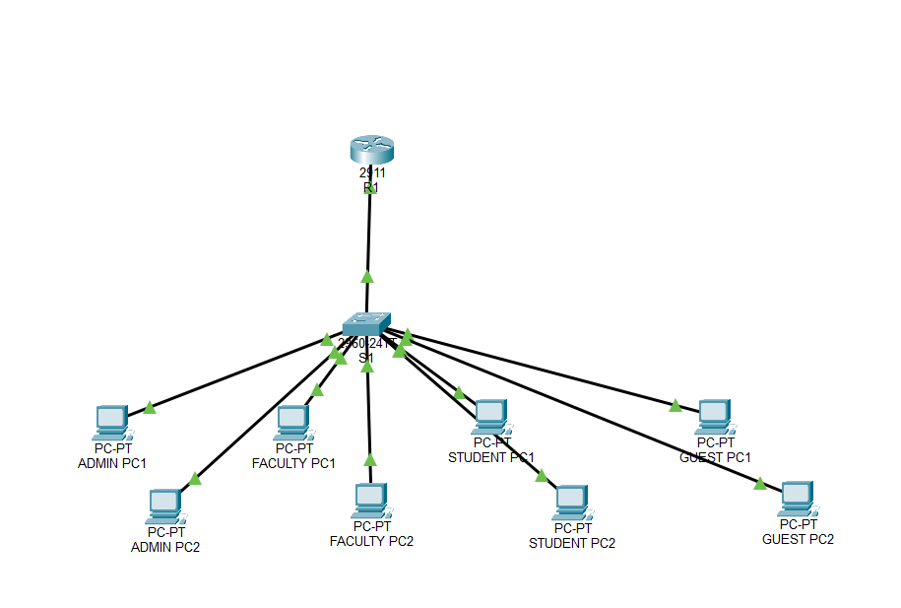
Figure 1: VLAN-based enterprise LAN topology created using Cisco Packet Tracer.

Screenshot 2 – VLAN Configuration
Show:
show vlan brief
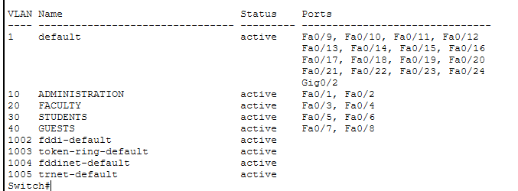
Figure 2: Verification of Administration, Faculty, Students and Guests VLANs.

Screenshot 3 – Trunk Configuration
Show:
show interfaces trunk
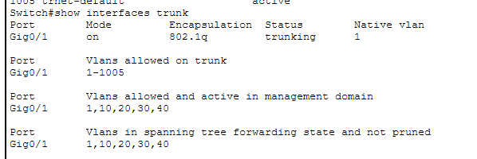
Figure 3: Verification of trunk connection between switch and router.

Screenshot 4 – Router Interfaces
Show:
show ip interface brief
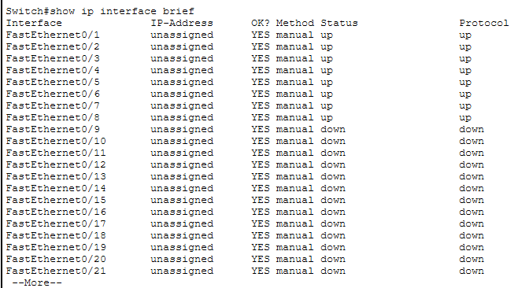
Figure 4: Verification of router subinterfaces and IP addresses.

Screenshot 5 – Administration Ping, – Inter-VLAN Ping
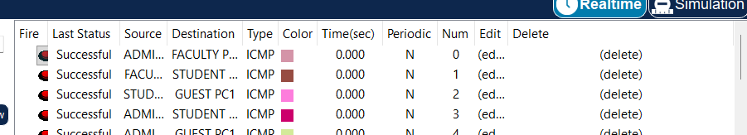
Figure 5: Output of the Topology

26. TROUBLESHOOTING AND ANALYSIS
During network implementation, several configuration issues can potentially prevent connectivity.
Problem 1 – Incorrect VLAN Assignment
Cause
A PC may be connected to a switch port belonging to the wrong VLAN.
Solution
Check:
show vlan brief
Then assign the correct VLAN:
interface fa0/x
switchport mode access
switchport access vlan 10

Problem 2 – Trunk Not Configured
Cause
The switch-router connection may be configured as an access port instead of a trunk.
Solution
interface gigabitEthernet 0/1
switchport mode trunk

Problem 3 – Incorrect Default Gateway
Cause
A PC may have the wrong gateway.
Solution
Use:
Administration → 192.168.10.1
Faculty → 192.168.20.1
Students → 192.168.30.1
Guests → 192.168.40.1

Problem 4 – Router Interface Shutdown
Cause
The physical router interface may be administratively down.
Solution
interface gigabitEthernet 0/0
no shutdown

Problem 5 – Incorrect IP Address
Cause
A PC may be configured with an address belonging to another subnet.
Solution
Verify the IP configuration and ensure that each device belongs to the correct VLAN subnet.

27. ANALYSIS OF THE SOLUTION
The VLAN-based solution provides several benefits.
27.1 Improved Segmentation
Each department operates in its own logical broadcast domain.
27.2 Better Traffic Management
Broadcast traffic from one department is not automatically propagated throughout all VLANs.
27.3 Improved Organization
Devices can be grouped logically according to their function rather than only their physical location.
27.4 Scalability
Additional computers can be added to the appropriate VLAN without redesigning the entire network.
27.5 Centralized Routing
The router provides communication between different VLAN networks.

28. COMPARISON OF ALTERNATIVES
Feature | Single LAN | VLAN-Based LAN
Department separation | Low | High
Broadcast domain | Single | Multiple
Traffic management | Limited | Better
Logical organization | Low | High
Scalability | Moderate | High
Security/segmentation | Lower | Better
Configuration complexity | Low | Moderate
Inter-department routing | Not required | Required

29. TRADE-OFFS
The VLAN-based design has both advantages and disadvantages.
Advantages
- Better network segmentation.
- Improved traffic management.
- Better organization.
- Scalable architecture.
- Easier departmental management.
- Supports controlled inter-VLAN communication.
Disadvantages
- Configuration is more complex than a single LAN.
- Inter-VLAN routing requires a router or Layer 3 switch.
- Incorrect VLAN or trunk configuration can cause connectivity problems.
- Network administrators require additional configuration knowledge.
The final design was selected because the benefits of logical segmentation and improved network management outweigh the additional configuration complexity.

30. BROADER CONSIDERATIONS AND SDG RELEVANCE
The assignment document explicitly maps the activity to SDG 4, SDG 9 and SDG 11.
SDG 4 – Quality Education
The assignment provides practical experience in computer networking, network configuration, simulation and troubleshooting. It develops technical and analytical skills through hands-on implementation.
SDG 9 – Industry, Innovation and Infrastructure
This project is strongly related to SDG 9 because it focuses on designing reliable, organized and scalable ICT infrastructure. VLAN segmentation is commonly relevant to enterprise networks where performance, security and manageability are important.
The assignment rubric specifically expects a strong connection to SDG 9 and its relevance to secure and efficient digital infrastructure.
SDG 11 – Sustainable Cities and Communities
Reliable network infrastructure supports connected campuses, smart buildings, digital services and connected communities. The assignment develops networking skills applicable to such environments.

31. PROFESSIONAL AND ETHICAL CONSIDERATIONS
Network administrators have a responsibility to maintain reliable and secure network infrastructure.
Important considerations include:
- Protecting network resources.
- Preventing unauthorized access.
- Maintaining confidentiality of network information.
- Properly documenting configurations.
- Avoiding unauthorized network testing.
- Using network resources responsibly.
- Implementing appropriate access controls in real deployments.
The simulated network demonstrates segmentation but does not represent a complete enterprise security architecture.

32. CONCLUSION
The VLAN-based enterprise LAN was successfully designed using Cisco Packet Tracer.
Four separate VLANs were created for:
- Administration
- Faculty
- Students
- Guests
Each VLAN was assigned a dedicated IP subnet and appropriate switch ports. A trunk connection was configured between the switch and router, while router subinterfaces were used to implement inter-VLAN routing.
Connectivity was verified using ping and Cisco IOS verification commands.
The implementation demonstrates that VLANs can provide effective logical network segmentation while still allowing communication between authorized departments through routing.
The assignment successfully applies concepts including VLANs, switching, trunking, IP addressing, subnetting, routing, inter-VLAN communication and network troubleshooting.

33. LIMITATIONS
The proposed implementation has the following limitations:
- Only one router is used.
- Only one switch is used.
- The network is simulated rather than deployed physically.
- No dedicated firewall is implemented.
- No DHCP server is included.
- No wireless network is included.
- No Internet connection is included.
- Advanced access-control policies are not implemented.
- Network redundancy is not implemented.
- Performance measurements are limited because the network is simulated.

34. POSSIBLE IMPROVEMENTS
The network can be improved in future by:
- Adding multiple switches.
- Adding redundant links.
- Using a Layer 3 switch for routing.
- Implementing DHCP.
- Adding firewall protection.
- Implementing Access Control Lists (ACLs).
- Adding wireless access points.
- Implementing network monitoring.
- Adding authentication mechanisms.
- Introducing redundancy for improved reliability.
- Implementing separate security policies for Guest users.
- Measuring network performance under different traffic loads.

35. INDIVIDUAL CONTRIBUTION OF GROUP MEMBERS
Replace the names with your actual group members.
Member | Contribution
Member 1 – __________ | Network topology design and VLAN planning
IP addressing and switch configuration
Router and inter-VLAN routing configuration
Testing, troubleshooting and result analysis
Documentation, screenshots and GitHub upload

37. ONE-PAGE INDIVIDUAL REFLECTION
Individual Reflection
This assignment provided me with practical experience in designing and configuring a VLAN-based enterprise network using Cisco Packet Tracer. Before implementing the network, I understood VLANs mainly as a theoretical networking concept. Through this assignment, I learned how VLANs can be practically used to divide a network into separate logical broadcast domains.
One of the important design decisions was to create four VLANs for Administration, Faculty, Students and Guests. This arrangement provides logical separation between departments and makes the network easier to manage. I also learned that VLAN segmentation requires appropriate IP addressing and switch-port configuration. Each VLAN was therefore assigned a separate subnet and default gateway.
Another important concept I learned was inter-VLAN routing. Since devices in different VLANs cannot communicate directly through Layer 2 switching, router subinterfaces were configured to provide communication between the VLANs. Configuring the trunk connection between the switch and router helped me understand how multiple VLANs can use a single physical connection.
During implementation, checking configurations was an important part of the process. Commands such as show vlan brief, show interfaces trunk and show ip interface brief helped verify whether the devices were configured correctly. Using the ping command also helped verify connectivity between devices in the same VLAN and between different VLANs.
The assignment also improved my troubleshooting skills. I learned that connectivity problems can result from incorrect IP addresses, incorrect VLAN assignments, trunk configuration problems, incorrect default gateways or router-interface issues. Instead of changing configurations randomly, I learned to identify the problem systematically and verify each part of the network.
The project is relevant to SDG 9 – Industry, Innovation and Infrastructure, because reliable and well-organized digital infrastructure is important for modern organizations. VLANs can contribute to better network organization, traffic management and logical segmentation. The assignment also supports SDG 4 – Quality Education by providing practical technical learning and hands-on networking experience. The assignment document identifies SDG 4, SDG 9 and SDG 11 as relevant mappings.
Overall, this assignment helped me connect theoretical Computer Networks concepts with practical implementation. I gained experience in VLAN configuration, switching, trunking, IP addressing, routing, connectivity testing and troubleshooting. If additional time and resources were available, I would improve the network by adding ACLs, DHCP, firewall security, redundancy, wireless connectivity and network monitoring. These improvements would make the simulated enterprise network more realistic, secure and scalable.

38. REFERENCES
- Cisco Networking Academy, Cisco Packet Tracer, Cisco Systems.
- Cisco Systems, Cisco IOS Configuration Guides, Cisco Documentation.
- Cisco Systems, VLAN Configuration Guide, Cisco Documentation.
- Cisco Systems, Inter-VLAN Routing Configuration, Cisco Documentation.
- Cisco Systems, Ethernet Switching Concepts, Cisco Documentation.
- Cisco Systems, IP Addressing and Subnetting, Cisco Documentation.
- Cisco Systems, IEEE 802.1Q VLAN Trunking Concepts, Cisco Documentation.
- Andrew S. Tanenbaum and David J. Wetherall, Computer Networks, Pearson.
- James F. Kurose and Keith W. Ross, Computer Networking: A Top-Down Approach, Pearson.
- Behrouz A. Forouzan, Data Communications and Networking, McGraw-Hill.
- William Stallings, Data and Computer Communications, Pearson.
- Cisco Networking Academy, Introduction to Networks, Cisco.
- Cisco Networking Academy, Switching, Routing, and Wireless Essentials, Cisco.
- IEEE, IEEE 802.1Q – Virtual Bridged Local Area Networks, IEEE Standards.
- United Nations, Sustainable Development Goals, United Nations.

